**8.2.1**

What's that?

That's for acting class. **It's my registration form**. Can you help me?

Yes. I can help you. This question is easy. **What's your name?**

**My name is Shen Li**

**Next. What's your address?**

**My address is 746 West Brooks avenue = street**

**Alright. How old are you?**

I'm 23 years old

Good. **Where are you from?**

**I'm from China**

Next question. **What languages do you speak?**

I speak English and Chinese

Perfect. Now. It's tell about you

That isn't a question

You're right. **They want to know about you**, **your family or what you like**. Give that pen and paper. I want to make a list for you

What’s your name?

* My name is Shen Li

What’s your address?

* 7-4-6 Brooks Avenue

How old are you?

* I’m twenty-three years old

Where are you from?

* I’m from China

What languages do you speak?

* I speak English and Chinese

My address is 1-4-0 Brooks Street

I’m thirty-one years old

I’m from Thailand

My name is Benny King

I speak Hindi and Punjabi

Put registration form is this

It’s my form. Can you help me?

Yes. I can. What’s your address?

My address is 7-4-6 Brooks Street

Okay. Oh. And what’s your name?

My name’s Shen Li

And how old are you? Are you 23?

Yes. I’m 23 year old

Okay. Where are you from?

I’m from China

What language do you speak?

I speak English and Chinese

Can you help me?

What’s your name?

* My name is Khae

What’s your address?

* My address is 2-0-5 Brooks Street

Where are you from?

* I’m from England

What’s languages do you speak?

**8.2.2**

What are your hobbies?

Hobbies? I don’t understand

A hobby is what you do when you are not acting

Okay. I live with you

That isn’t hobby. Do you play sports? Do you like tennis?

No. I don’t like tennis

Do you like basketball?

No. I don’t like basketball

Do you like cricket?

No. I don’t like cricket

Do you like to sing? Do you like to sing?

I don’t like to sing

You can’t sing. Do you like to dance?

No. But you can dance

Do you like books?

I like movies. Is that hobby?

Yes. It is

I like movies

What do Shen and Benny talk about?

* Hobbies

Does Shen like tennis?

* No. He does not like tennis

Shen is bad at singing

Benny can’t dance

What is Shen’s hobby?

* He likes movies

They like to play cricket

She likes to read

He likes to dance

She likes to sing

They like movies

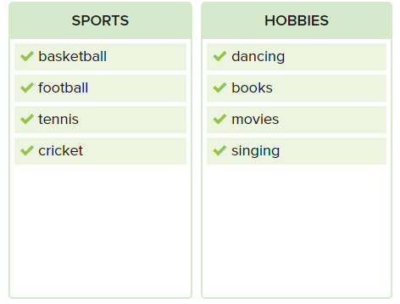

What are your hobbies, Benny?

I like to play cricket.

Wow, Do you like baseketball?

Yes, I like baseketball.

And tennis, Do you like to play tennis?

Yes, I like tennis.

Do you like to sing?

No, I don’t like to sing. I can’t sing

Do you like to dance?

Yes, I like to dance.

What are your hobbies?

--> I like movies

Do you play sports?

--> Yes, I play cricket

Do you like basketball?

Do you like to sing?

Do you like to dance?

Do you like book?

--> Yes, I liek to read

**8.2.3**

What is the next question?

The next question isn't a question. Your picture, what is your picture?

Those want to photo of you

I don't have a picture of me. Can you take a picture of me

Yes. I can take a picture of you

That picture isn't good

No, It isn't. Don't close your eyes!

Okay. Don't use this picture

Okay. Use this camera

I can't use this camera. I don't undersand it

It's easy

Smile. Don't smile

Thanks Benny.

Benny takes Shen's picture. Why?

--> Shen doen't have a picture

Benny takes the first picture, but Shen doesn't lie the picture

Shen helps Benny with the second camera. why?

--> He doen't understand it

Shen says "Thanks, Benny". Why?

--> The last picture is good

Shen, don't close your eyes.

No, it isn’t a good picture of you.

I don’t like football , but she likes football.

We can meet at seven o’clock.

You do not need your picture for this form.

Please, don’t smile for this picture.

My name is not Bill, but I know him.

No , he doesn’t want to come tomorrow.

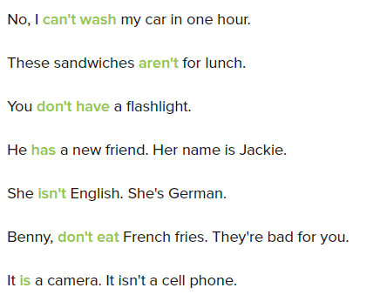

They want to photo of you.Do you have a picture?

No, I don't have a picture of me.

Do you have a camera?

No, I don’t have a camera

Do you have a phone?

Yes , I have a phone.

I can take a picture with your phone. Is it good?

No.That picture isn’t good.

That’s right. It’s bad. Don’t close your eyes and Don’t smile.

Okay. I want a good picture.

That’s right. Ok, one more.

No. Don’t take one more . I don’t want to take more.

Did you wash the plates?

No, I didn’t.

That apple is black. It isn’t good.

Don’t close the door.

Can I use this desk?

No, don’t use it.

Do you know her address?

No, I don’t know it.

Do you have a picture?

No, I don’t have a picture.

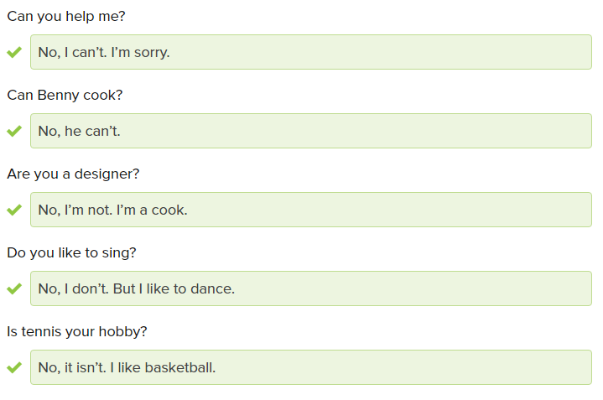

She is not a designer.

Benny can’t speak Chinese.

I like basketball.

I like a read.

I like singing.

I like tennis.

I can’t play basketball.

Jin-Young does not have food in her office.

Marco, do not eat the sanwich !It is not good.

Martin can’t say this word. The word is not easy.

Allison can’t dance.

Jose does not have a new car.

What are your hobbies?

I play basketball and tennis.

I like football.

Do you like sports?

Yes, I like cricket.

What are your hobbies?

I like reading and playing sports.

DS Workbooks 